Pokhara University

Level: Bachelor | Semester – Fall | Year : 2010
Programme: BE |  | Full Marks : 100
 |  | Pass Mark : 45
Course: Applied Mechanics |  | Time : 3 hrs

Candidates are required to give their answers in their own words as far as practicable.
The figures in the margin indicate full marks.

Attempt all the questions.

1. | - Determine the magnitude of force F so that the resultant F_{R} of the three forces is small as possible. What is the magnitude of F_{R}?  - Replace the two forces acting on the bent pipe by a single equivalent force R at A. Specify the distance y from point A to the line of action of R.  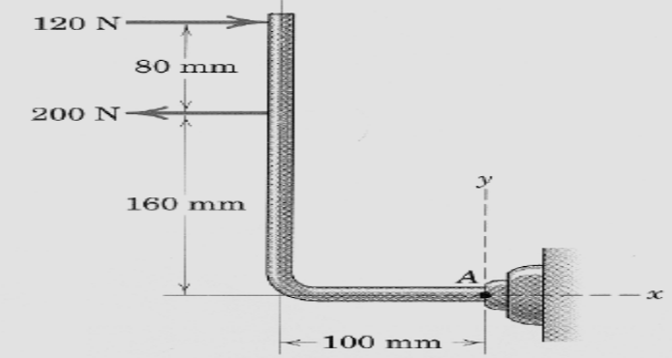 | 7  8
2. | - What should be the value of angle so that motion of the 90N block impends down the plane? The coefficient of friction for all surfaces is 1/3.  - Locate the moment of inertia of the area bounded by the curves as shown.  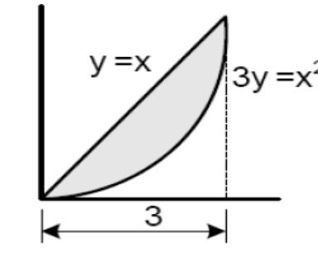 | 7  8
3. | - The acceleration of the particle is defined by the relation a=9-3t². The particle starts at t=0 with v=0 and x=15m. Determine  - The time when velocity is again zero  - The position and velocity when t=4s  - The total distance travelled by the particle from t=0 to t=4s  - As cam A rotates, follower wheel B rolls without slipping on the face of the cam. Knowing that the normal components of the acceleration of the points of contact at C of the cam A and the wheel B are 0.66m/s² and 6.8m/s² respectively. Determine the diameter of the follower wheel as overlaid in the figure.  OR  A ball is dropped vertically on to 20⁰ inclined plane at A. The direction of rebound forms an angle of 35⁰ with the vertical. Knowing that the ball strikes the inclined plane at B, determine:  - The velocity of rebound at A  - The time required for the ball to travel from A to B | 7  8  8
4. | The two block shown are originally at rest. The coefficient of friction between the blocks and inclines are μ_{s} = 0.25 and μ_{k} = 0.2. Neglecting the masses of the pulleys. Determine  - The acceleration on each block  - The tension in the cable | 15
5. | A system consists of three particles A, B, C. We know that m_{A} = 3 kg, m_{B} = 2 kgand m_{C} = 4 kg that the velocities of the particles expressed in m/s are respectively, v_{A} = 4i + 2j + 2k, v_{B} = 4i + 3j, and v_{C} = -2i + 4j + 2k. Determine (a) the angular momentum of the system about O, (b) Linear momentum of the system and (c) Mass centre of the system  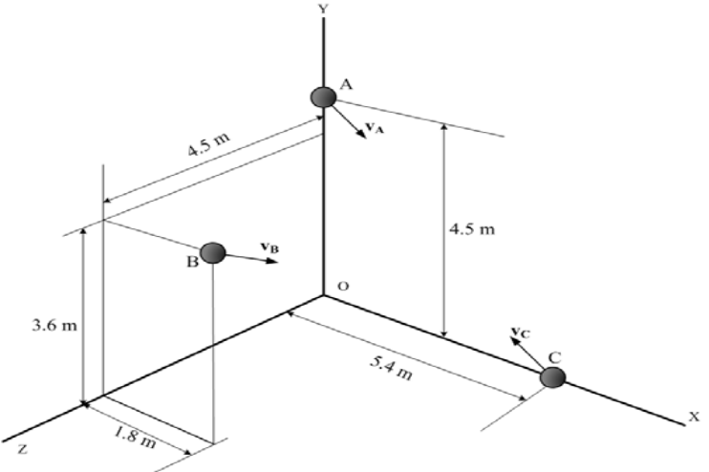 | 15
6. | A mixing drum of 125mm outside radius rests on two casters each of 25mm radius. The drum executed 15 revolutions during the time interval t, while its angular velocity is being increased uniformly from 20 to 50 rpm. Knowing that no slipping occurs between the drum and casters, determine; (a) Angular acceleration of the casters , (b)Time interval t  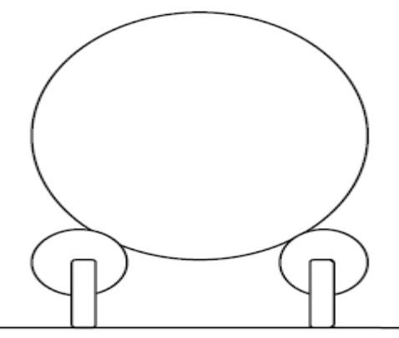  OR  A uniform rod for length L and mass m is supported as shown. If the cable attached at the end B suddenly breaks, determine (a) the acceleration of end B, (b) the reaction at the pin support | 15
7. | Write short notes on (Any Two):  - Projectile  - Centre of gravity  - Rigid body | 2×5

